**Assignment No 1**

Name : Priya Chougale

Roll No. : 323012

Batch : TY-C1

**Title**: Study the essential  linux commands for Cloud and DevOps.

**Theory:**

1. ls — The most frequently used command in Linux to list directories

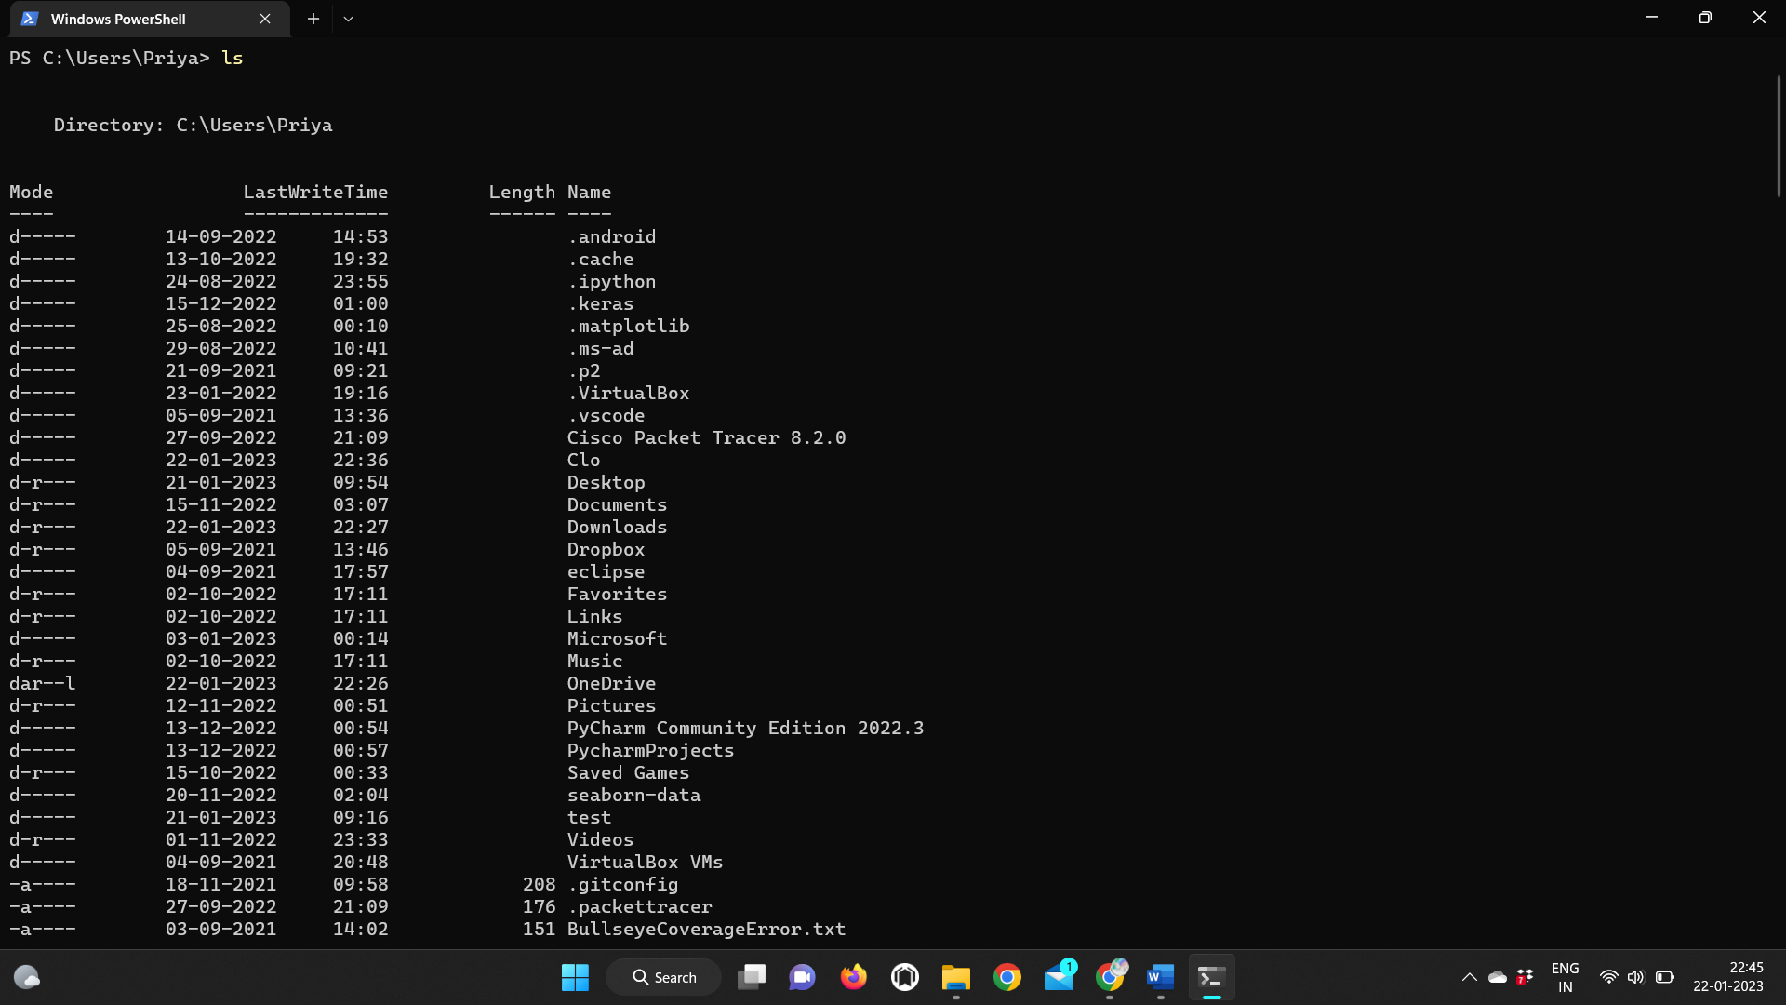

2. mkdir — Command used to create directories in Linux

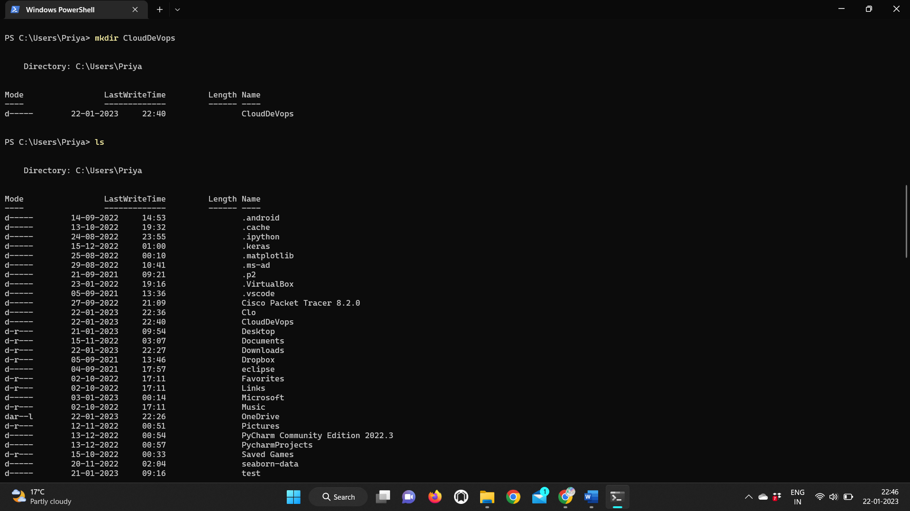

3. cd — Linux command to navigate through directories

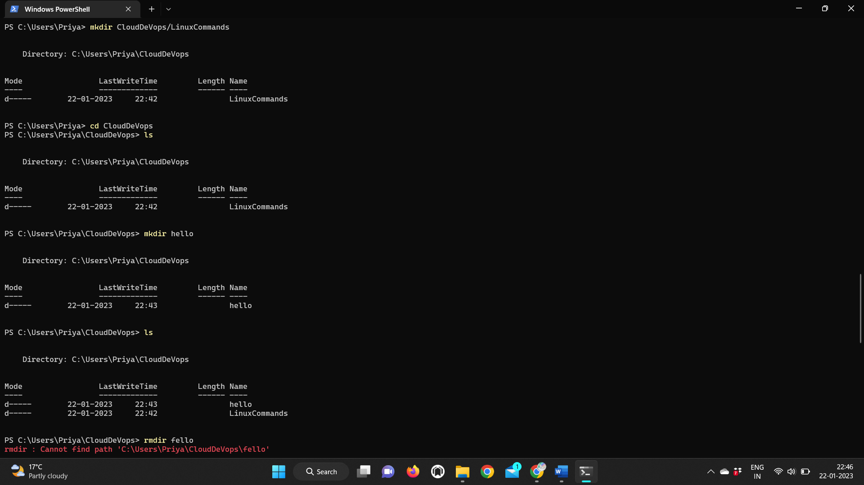

4. pwd — Print working directory command in Linux

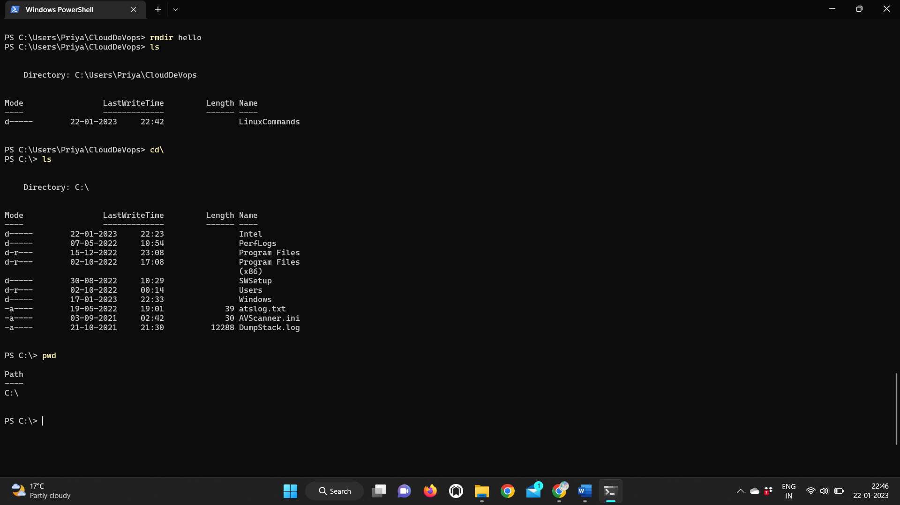

5. whoami — Get the active username

6. clear — Clear the terminal display

7. date -- used to check the current date, time in linux

8. man — Access manual pages for all Linux commands07. ln — Create symbolic links (shortcuts) to other files

9. ln — Create symbolic links (shortcuts) to other files

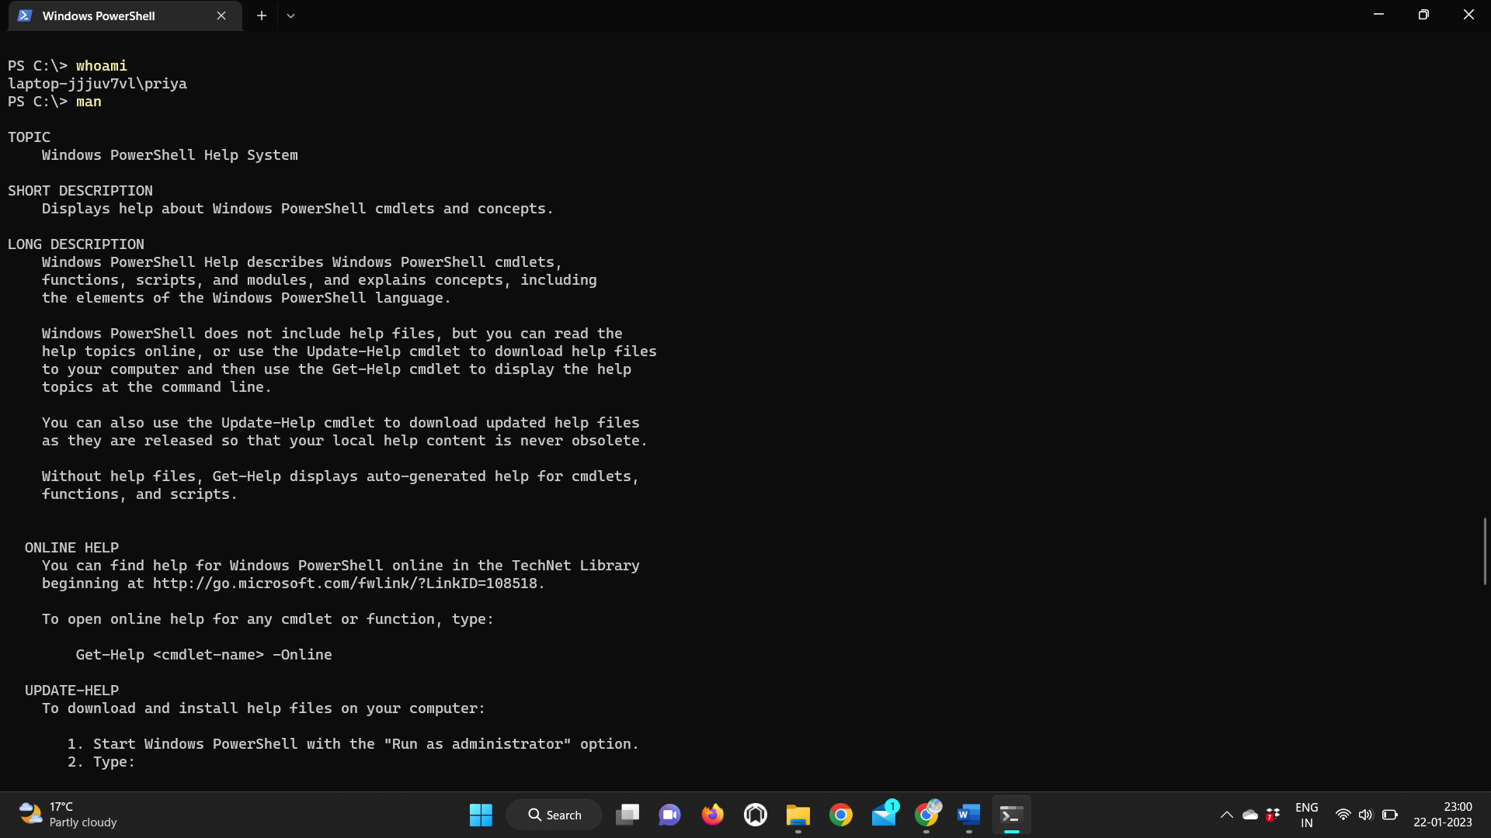

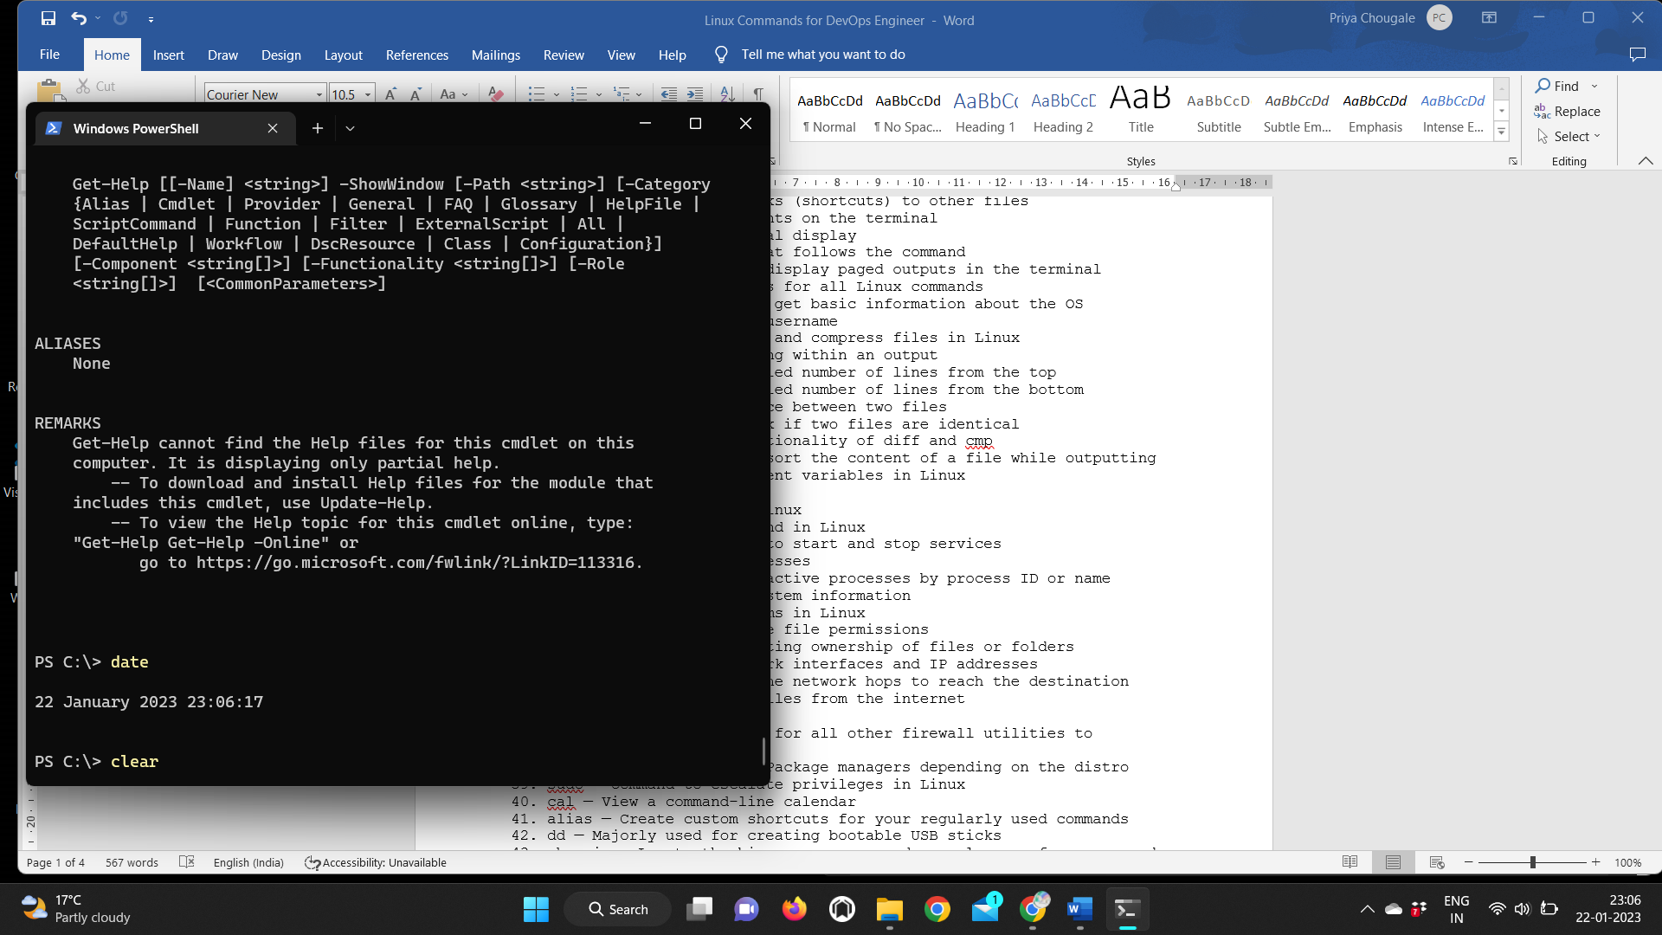

9. w -- to check how many users logged into the linux

10. ls -a --List the hidden files in directory (hidden files are denatoed as ..)

11. ls -l --Use to check the permissions on all the files

12. ls -R -- used to list information about files and directories within the file system.

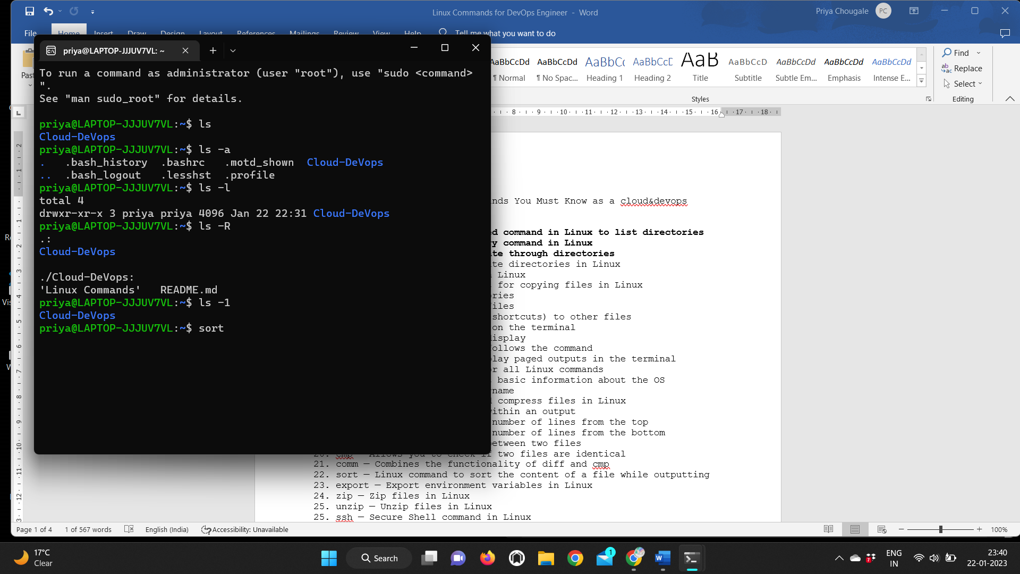

13. passwd — Create or update passwords for existing users

14. ls -1 | wc -l — Command to get the count of the files present into directory.

15. ifconfig — Display network interfaces and IP addresses

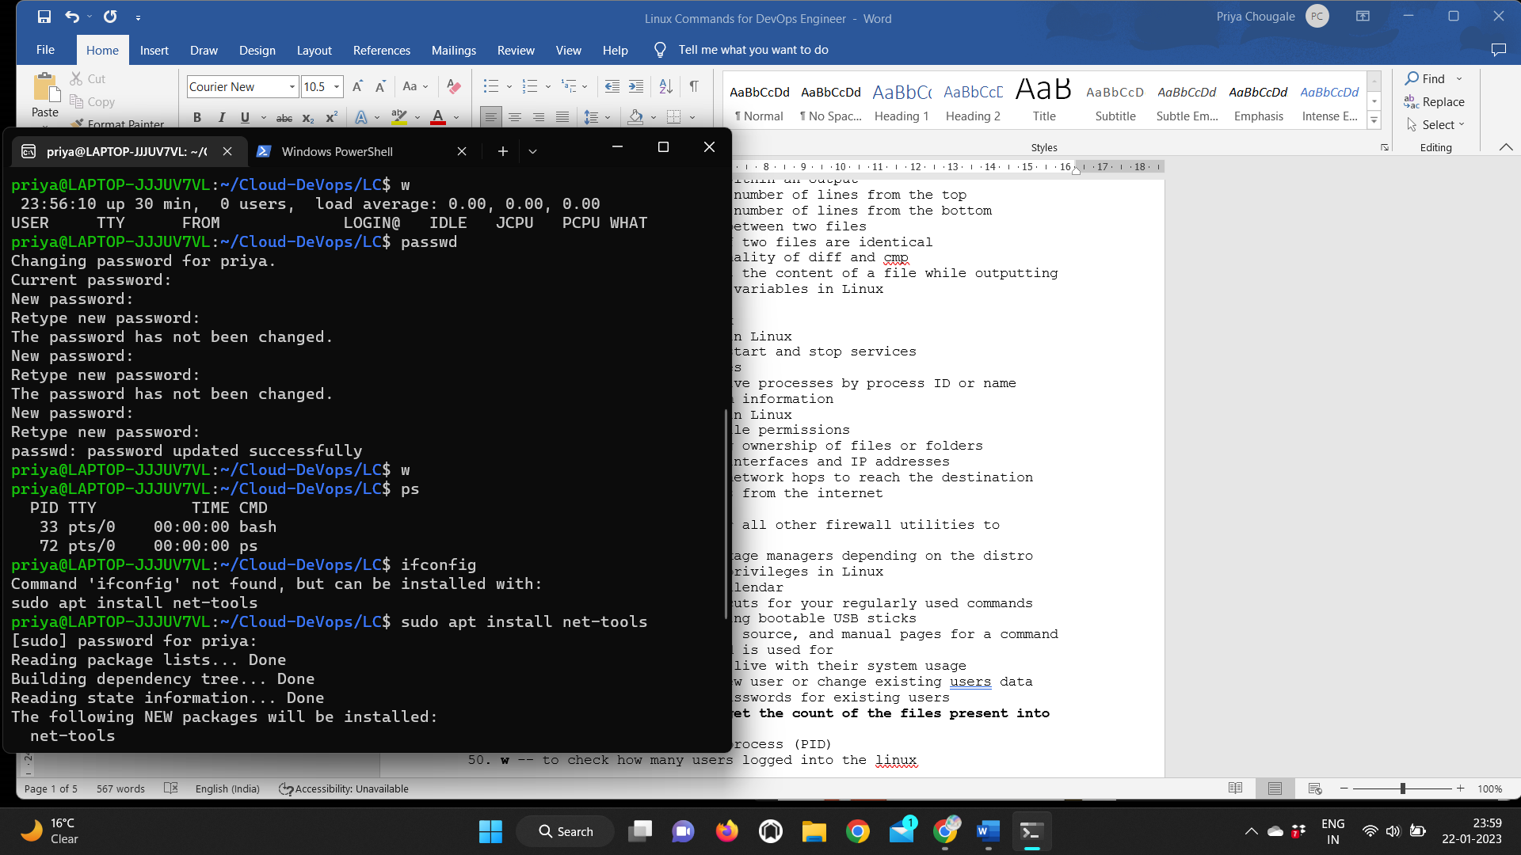

16. alias — Create custom shortcuts for your regularly used commands

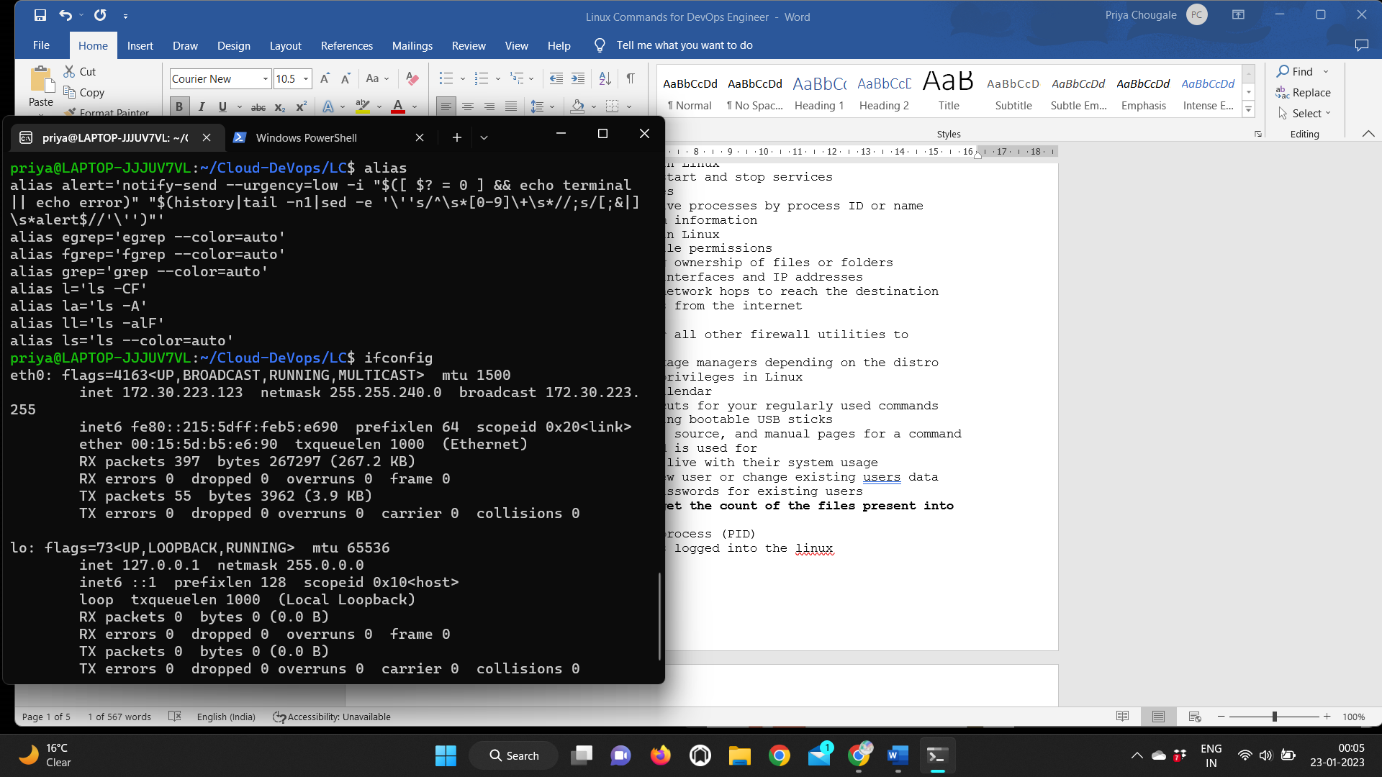

17. mv — Move or rename files in Linux

18. cp — Similar usage as mv but for copying files in Linux

19. rm — Delete files or directories

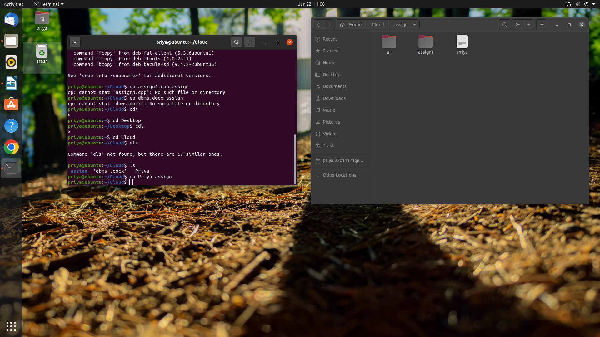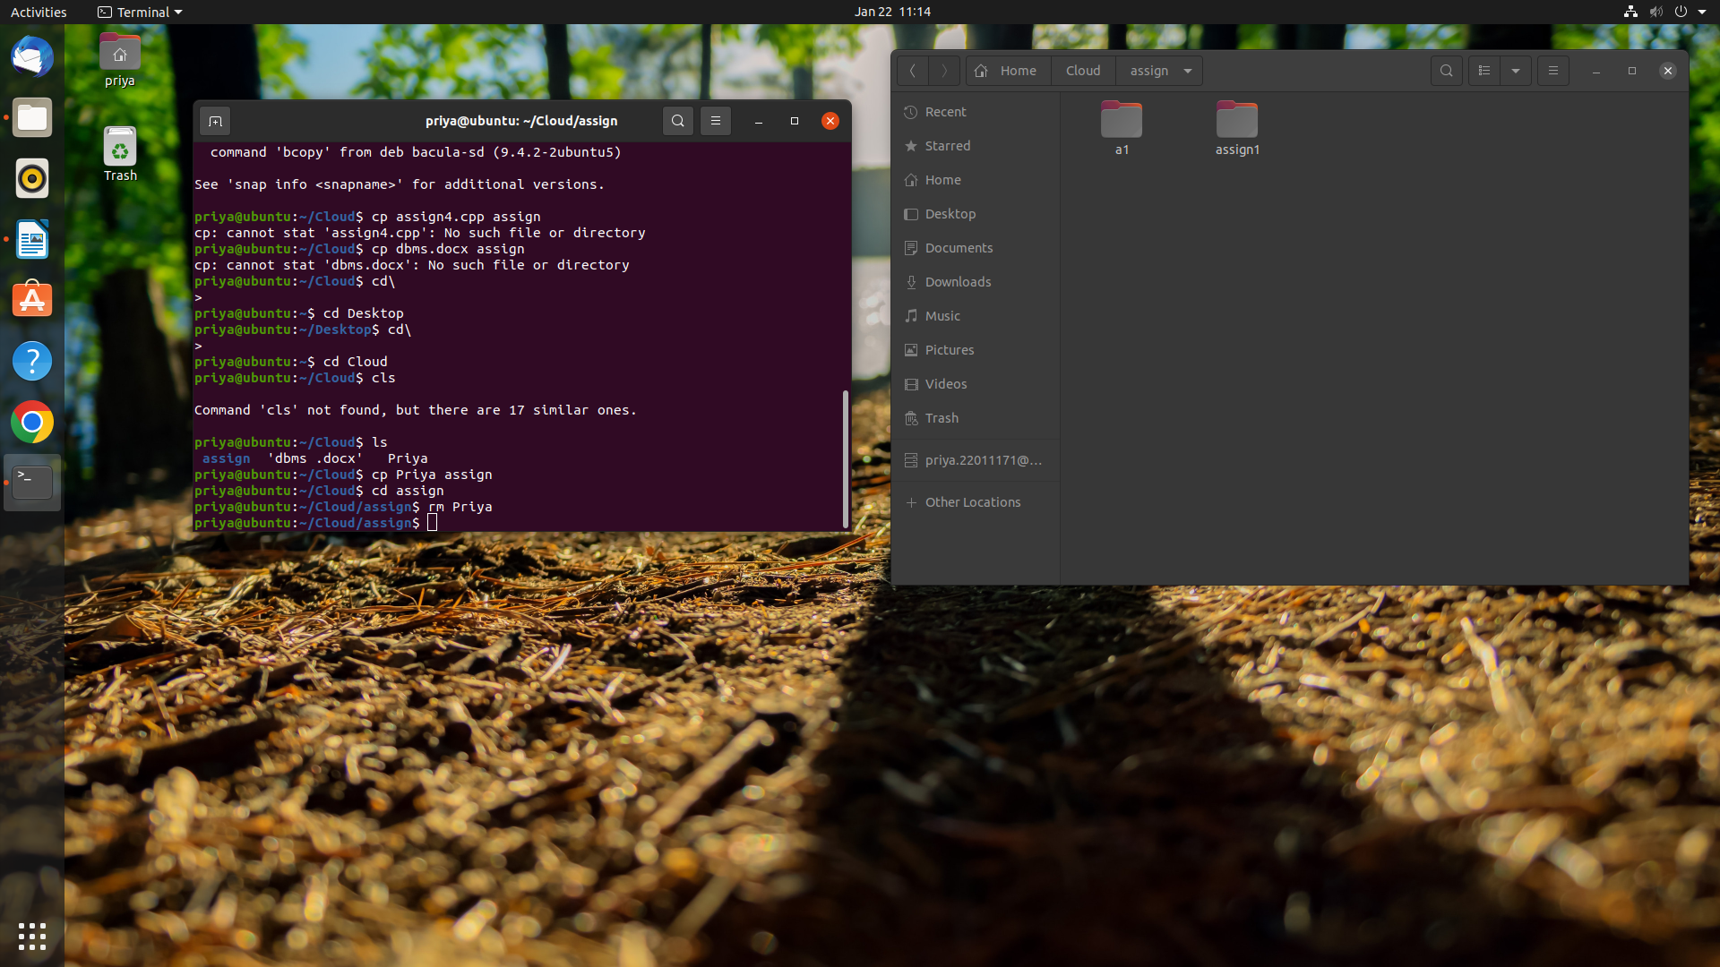

20. sudo — Command to escalate privileges in Linux

21. dd — Majorly used for creating bootable USB sticks

22. whereis — Locate the binary, source, and manual pages for a command

23. whatis — Find what a command is used for

24. rm -rf -- remove directory with the files

25. useradd and usermod — Add new user or change existing users data

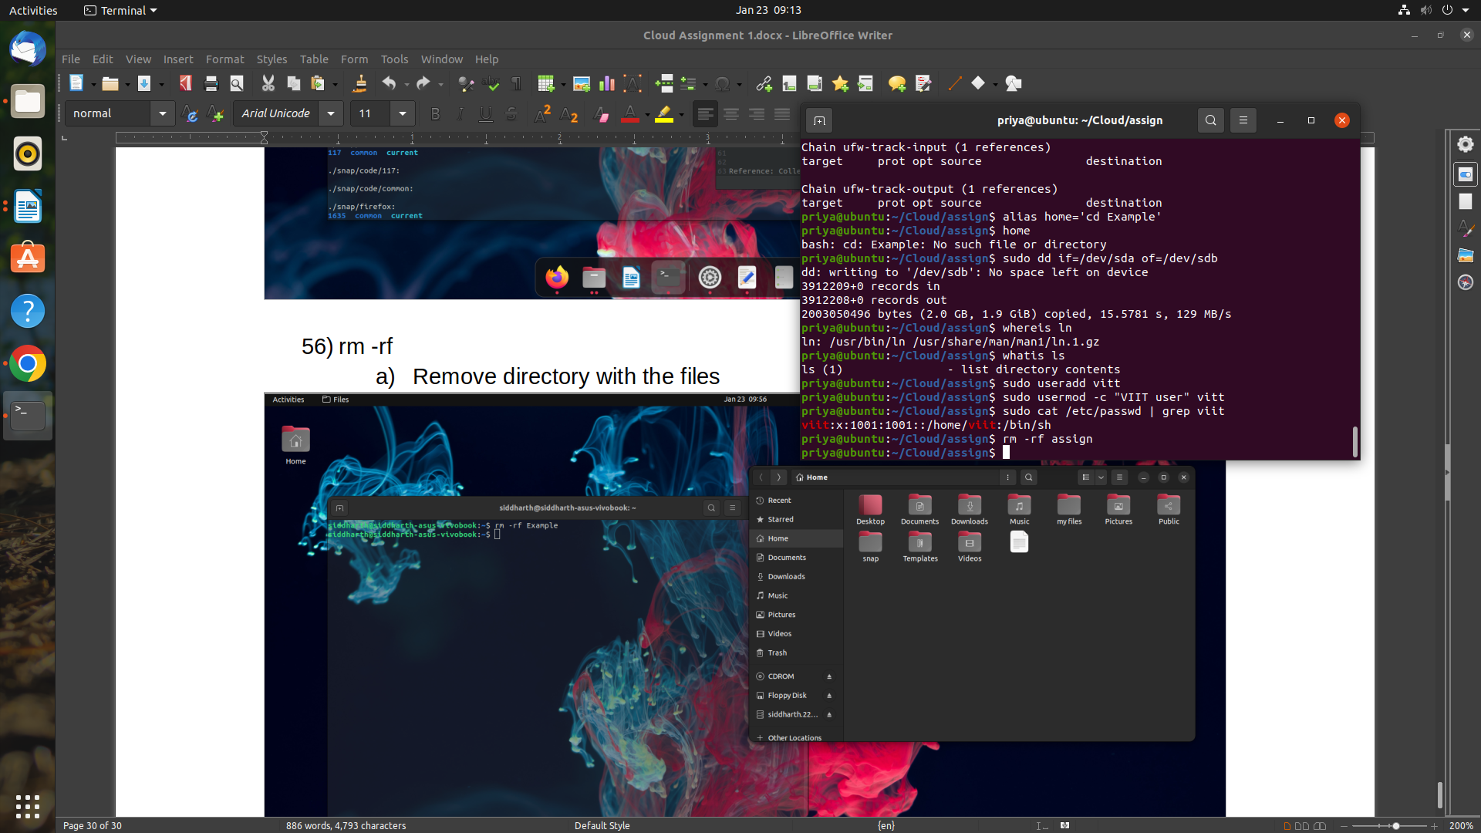

26. touch — Create blank/empty files

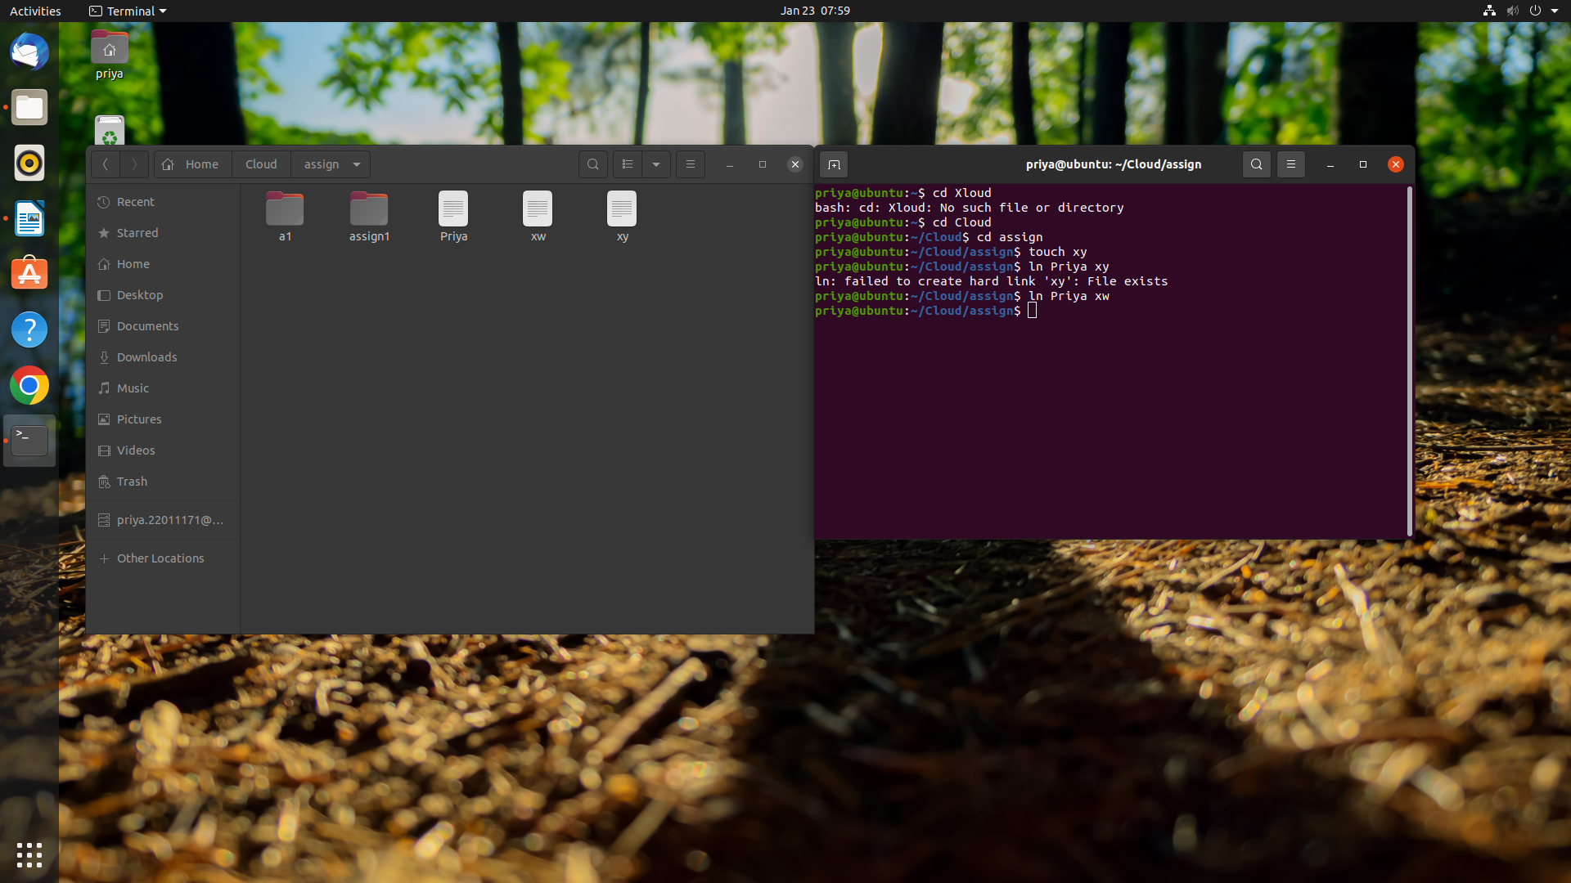

27. head — Return the specified number of lines from the top

28. tail — Return the specified number of lines from the bottom

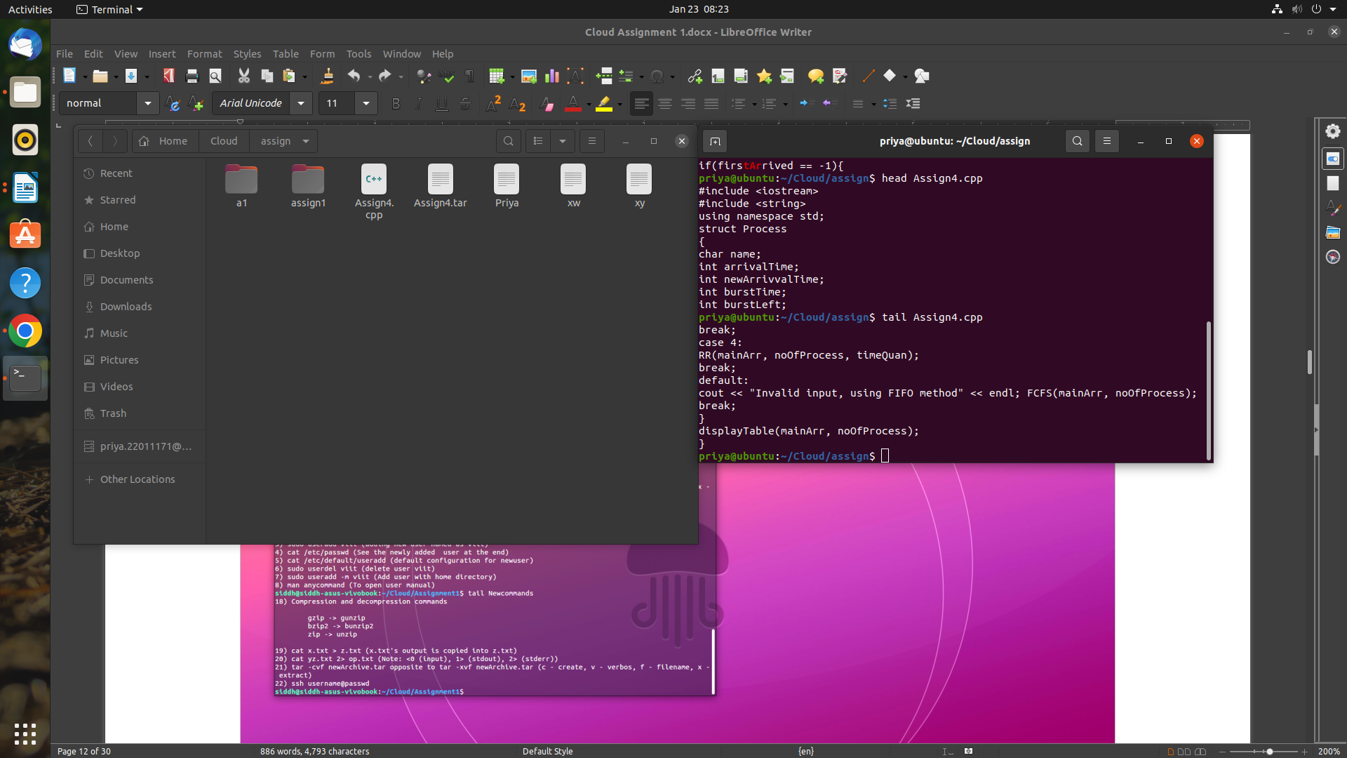

29. apt, pacman, yum, rpm — Package managers depending on the distro

30. wget — Direct download files from the internet

31. ufw — Firewall command

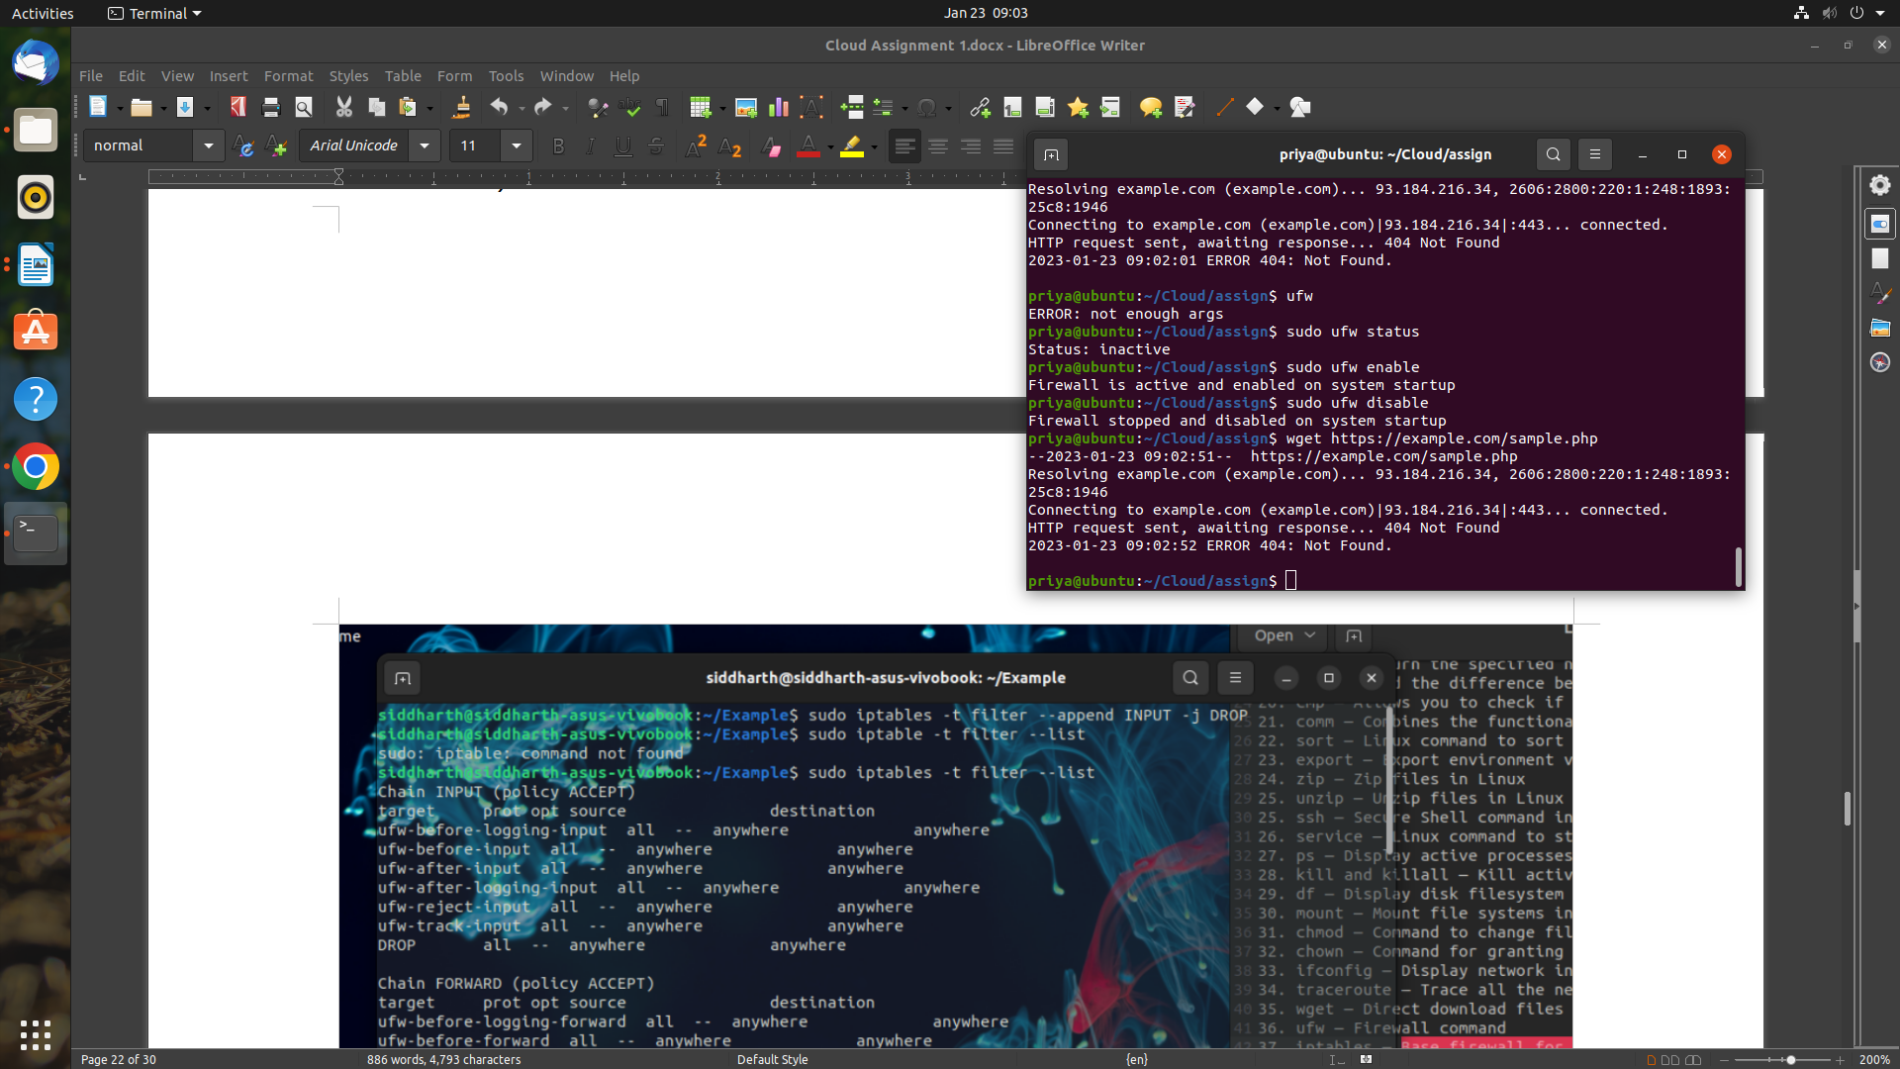

32. grep — Search for a string within an output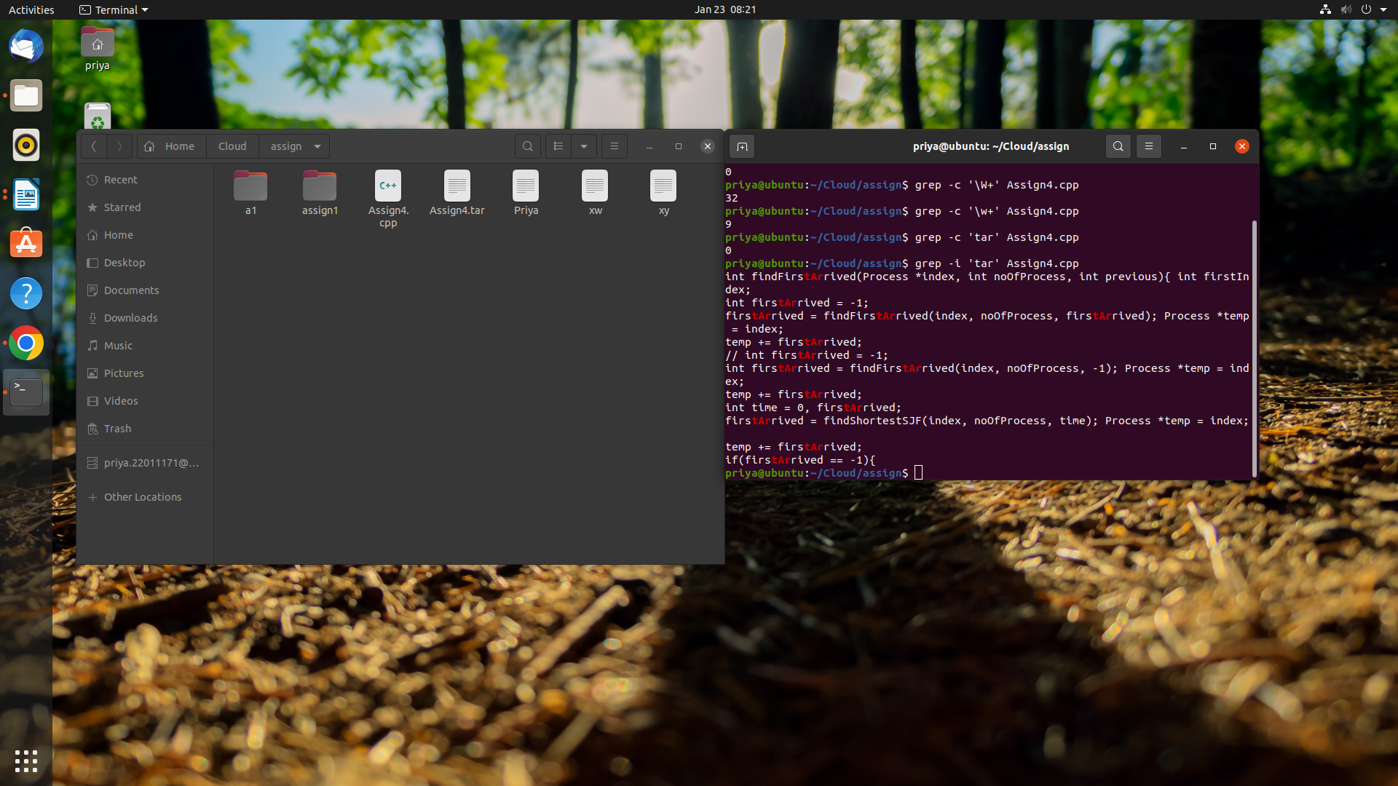

33. mount — Mount file systems in Linux

34. chmod — Command to change file permissions

35. chown — Command for granting ownership of files or folders

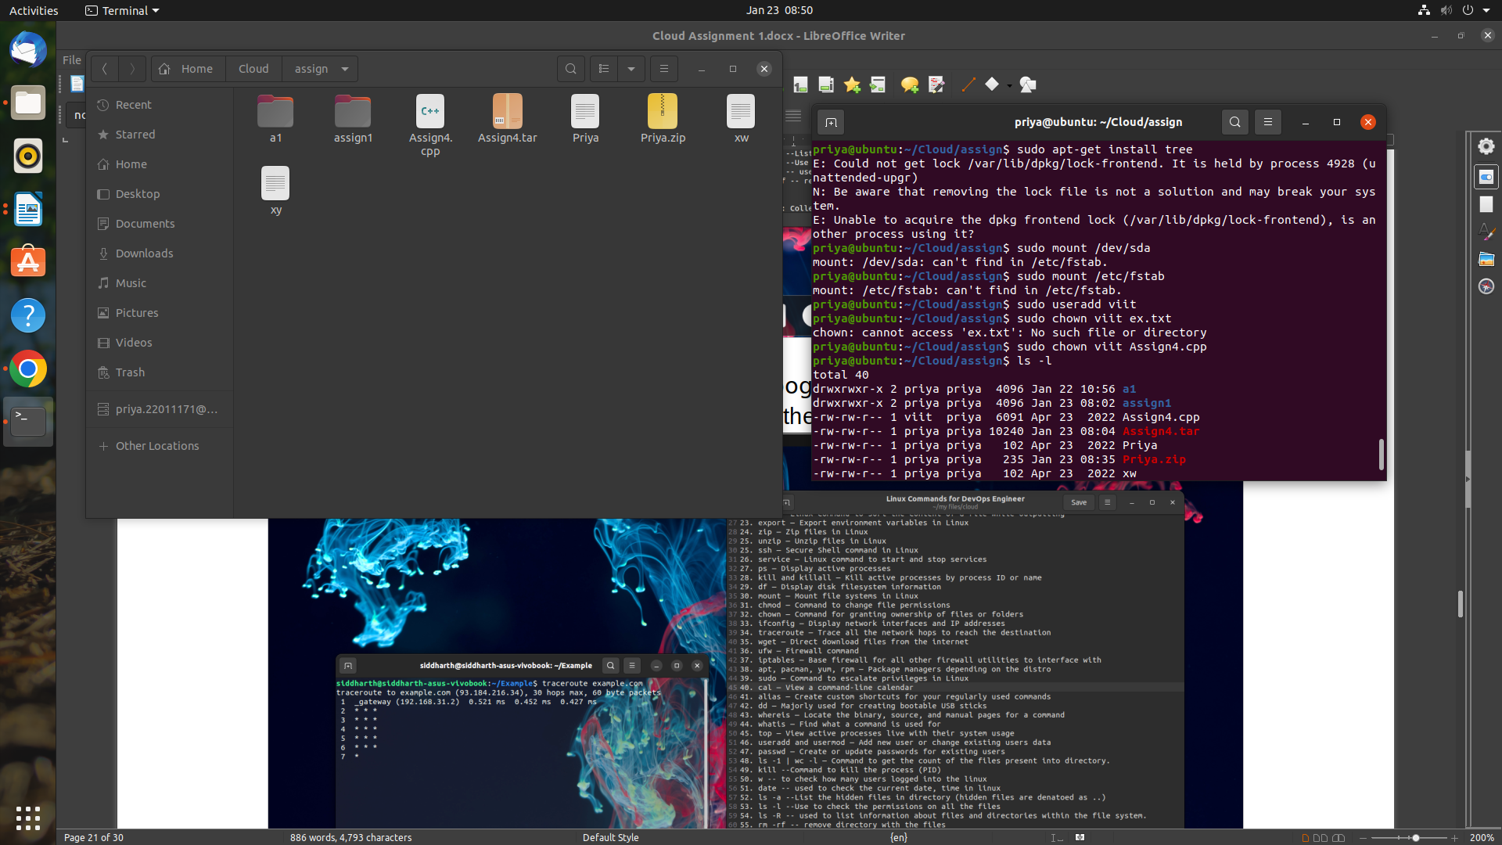

36. diff — Find the difference between two files

37. cmp — Allows you to check if two files are identical

38. comm — Combines the functionality of diff and cmp

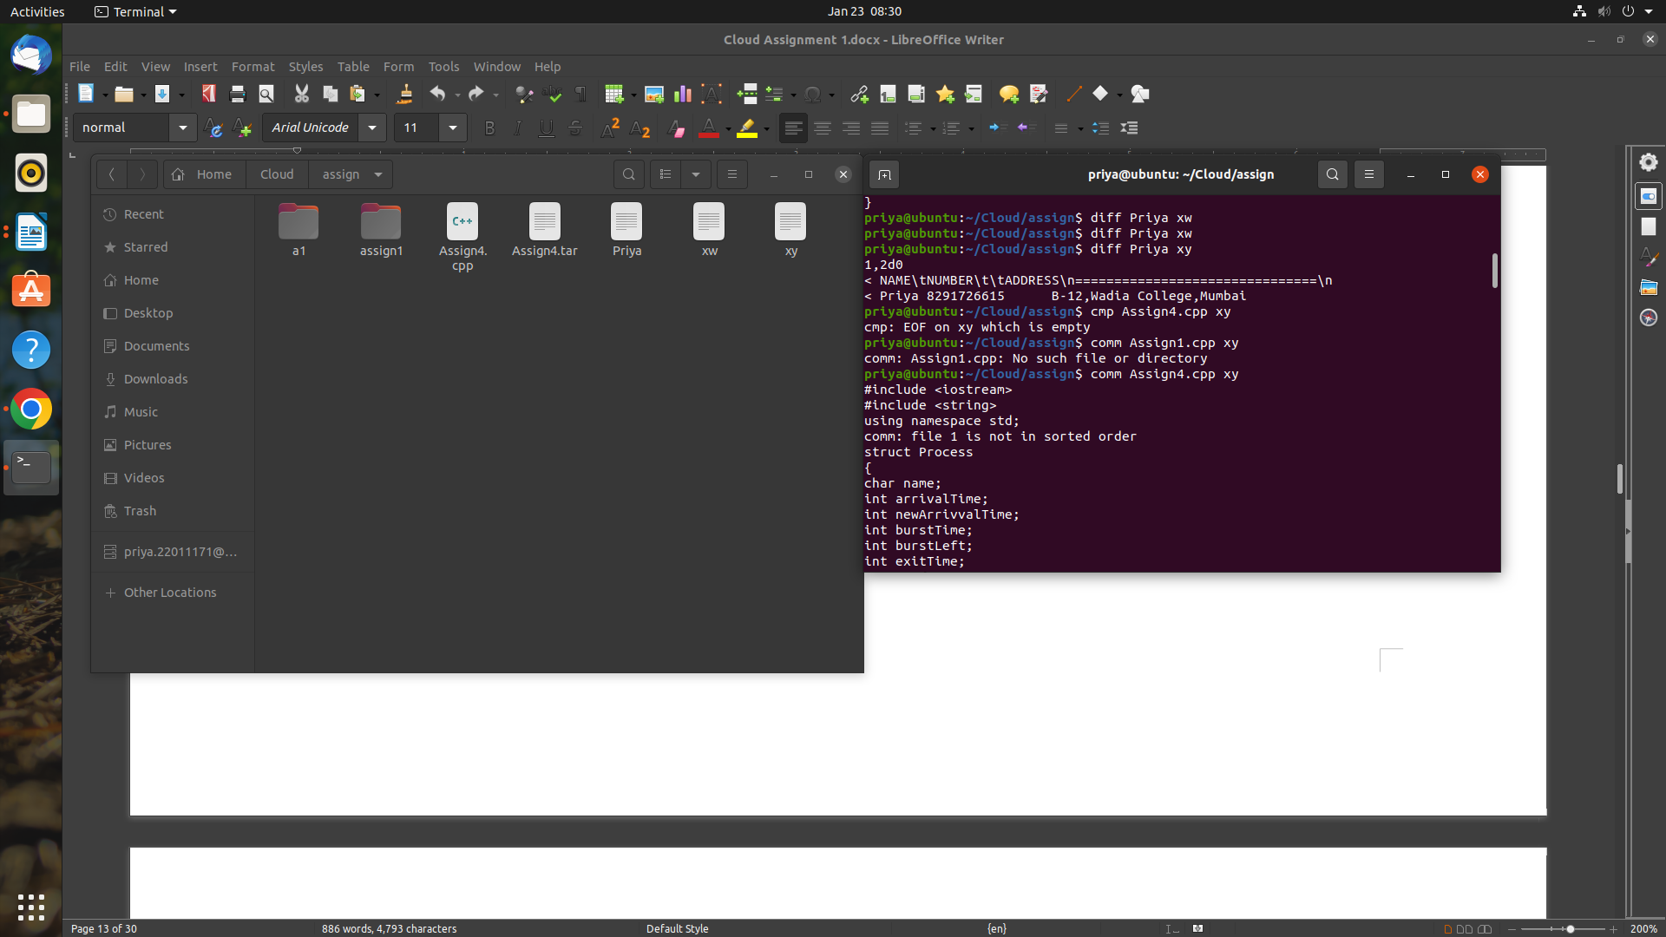

39. cal — View a command-line calendar

40. iptables — Base firewall for all other firewall utilities to interface with

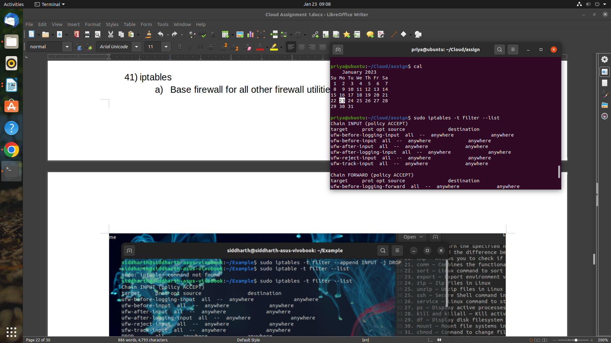

41. unzip — Unzip files in Linux

42. ssh — Secure Shell command in Linux

43. df — Display disk filesystem information

44. ps — Display active processes

45. kill and killall — Kill active processes by process ID or name

46. traceroute — Trace all the network hops to reach the destination

47. top — View active processes live with their system usage

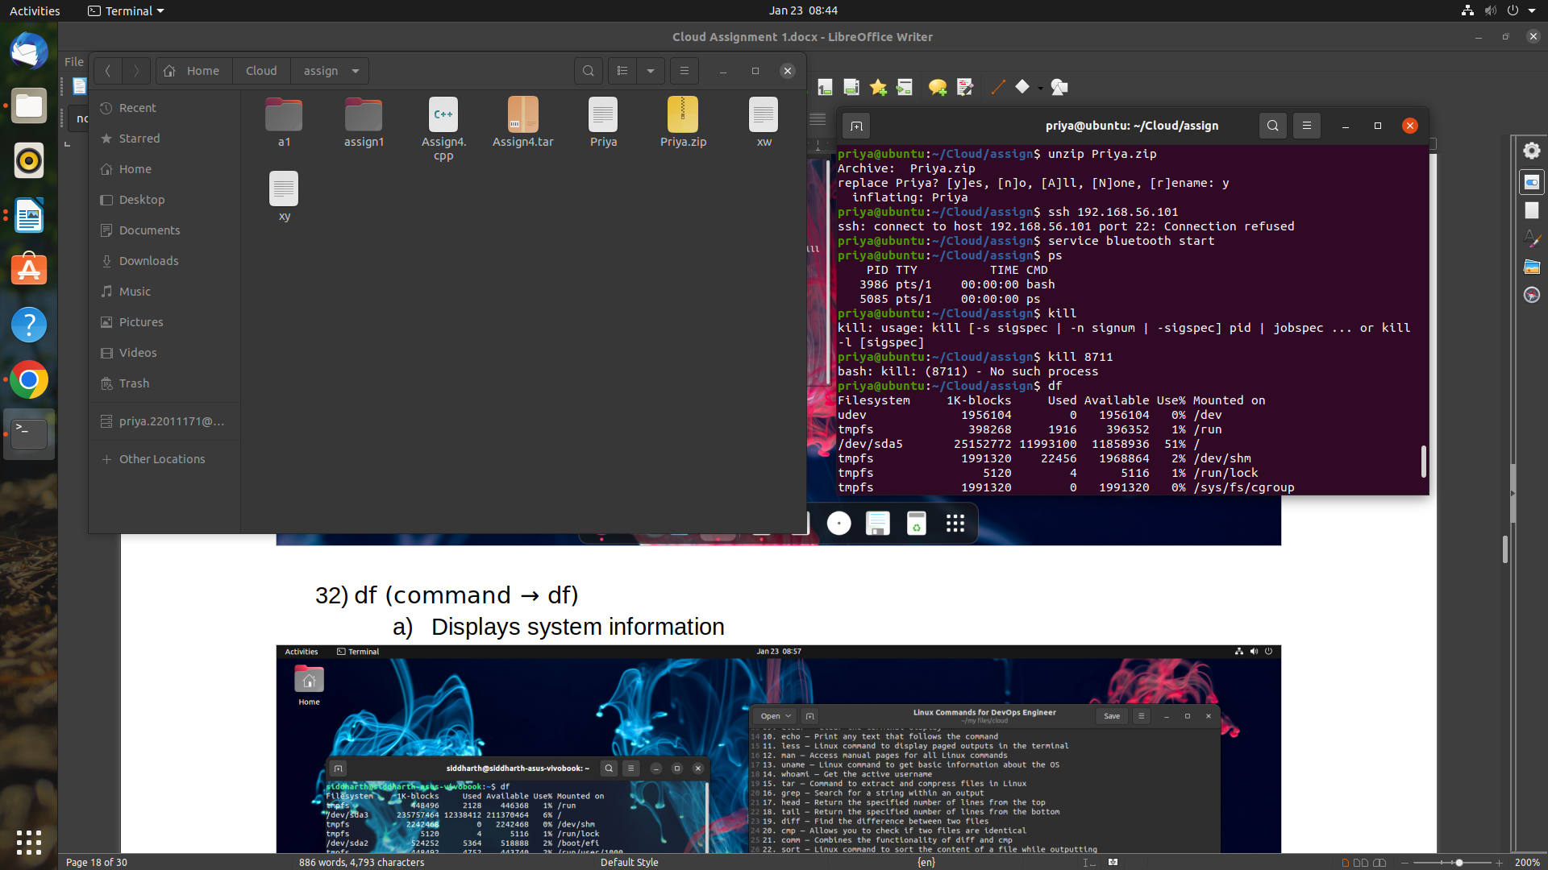

49. cat — Display file contents on the terminal

50. echo — Print any text that follows the command

51. less — Linux command to display paged outputs in the terminal

52. uname — Linux command to get basic information about the OS

53. tar — Command to extract and compress files in Linux

54. sort — Linux command to sort the content of a file while outputting

55. export — Export environment variables in Linux

56. zip — Zip files in Linux

57. service — Linux command to start and stop service

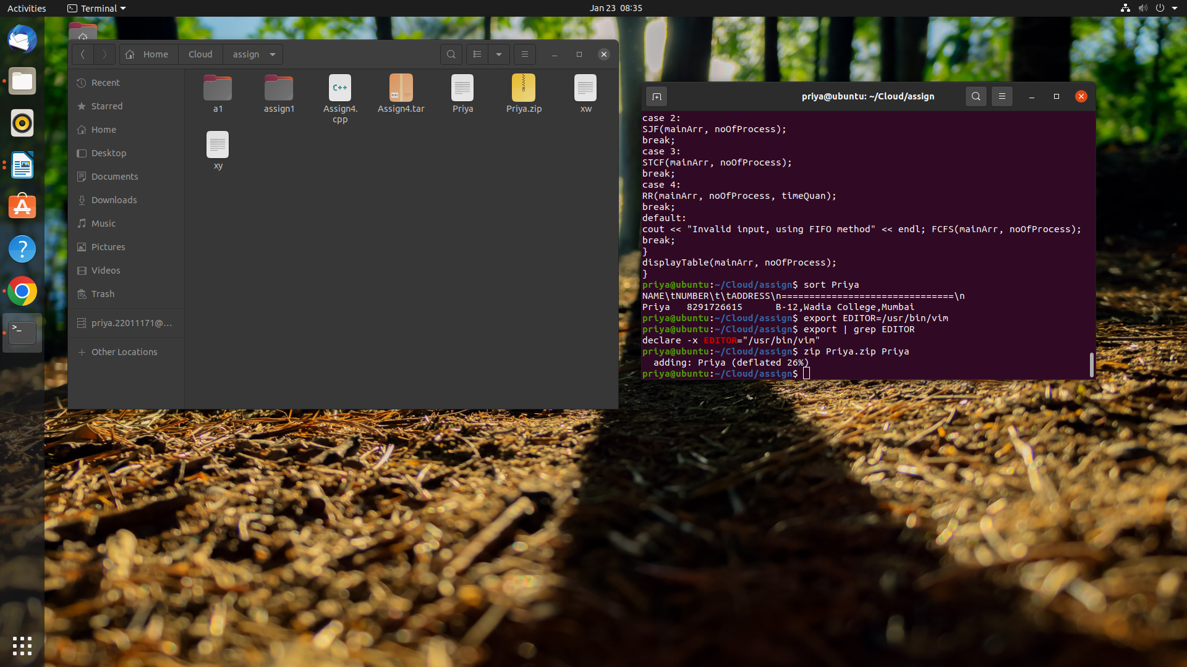

**Conclusion :**

Understood and performed various linux commands in Ubuntu and Terminal.